APF9.OBJ BUILD PROCEDURE
- Cleaning the build directories (optional)
  - Open cygwin.
  - cd to the apf9_new directory. (cygdrive/c/apf9_new)
  - cd src
  - make –f makefile.cygwin clean
  - cd ../lib
  - make –f makefile.cygwin clean
  - cd ../apf9lib
  - make –f makefile.cygwin clean
- Building the lib directory (only necessary if files in this directory have changed, or if you are starting from a clean build)
  - Open cygwin
  - cd to the apf9_new directory. (cygdrive/c/apf9_new)
  - cd lib
  - make –f makefile.cygwin (ignore any errors that appear)
  - Open MS-DOS prompt
  - cd to the apf9_new directory
  - cd lib
  - make –f makefile.dos (an error about FwRev.exe is expected, ignore this. Do not ignore any compiler errors that appear)
- Building the apf9lib directory (only necessary if files in this directory have changed, or if you are starting from a clean build)
  - Open cygwin
  - cd to the apf9_new directory.
  - cd apf9lib
  - make –f makefile.cygwin (ignore any errors that appear)
  - Open MS-DOS prompt
  - cd to the apf9_new directory
  - cd apf9lib
  - make –f makefile.dos (an error about FwRev.exe is expected, ignore this. Do not ignore any compiler errors that appear)
- Building the src directory
  - Open cygwin
  - cd to the apf9_new directory.
  - cd src
  - (legacy) make –f makefile.cygwin (ignore any errors that appear)
  - (legacy) Open MS-DOS prompt
  - cd to the apf9_new directory
  - cd src
  - make
(legacy) make –f makefile.dos (an error about FwRev.exe is expected, ignore this. Do not ignore any compiler errors that appear)
  - C:\PSDExpress\utladrm ..\psd\app
- The compiled, linked, and mapped binary file will be in apf9_new\psd\app.obj

PROGRAMMING PROCEDURE

- Hardware setup
  - Unplug all connections to the board
  - Put a jumper on JP3
  - Plug in the JTAG cable
  - Connect power
- Software
  - Open PSDsoft Express
  - Press Cancel then OK.
  - Click on JTAG ISP.
  - Choose one device in the chain.
  - Select the psd/app.obj file.
  - The device is PSD835G2V
  - Other options: Program/Verify, Region: All, Package: U (80-Pin TQFP), 4 pins.
  - Press execute, then yes.
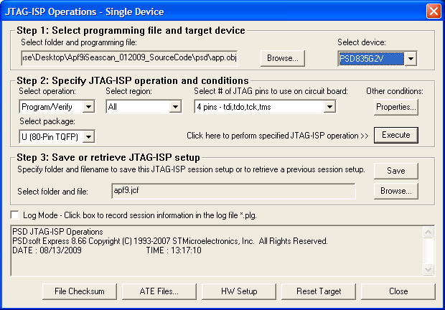

- Disconnect power, remove JP3 and the JTAG cable, replace connections, and apply power. The board is programmed.
- Do not save JTAG setup. (Save once when new project is created with a new subdirectory).

TODO:

- Implement $UPxxxx* command to be sent from the apf9 when it is going up. (probably in profile.c, but you will need to check to see if it is rising when that command is sent)
- Implement the query and response mechanism for the DSP. (Control.c)
- Add a buoy ID option of 0001 to the web RUDICS interface.
- Test how the apf9 downloads a new mission configuration during a simulated mission, not during recovery mode.

TO SET UP THE NEW BUILD ENVIRONMENT

- Install cygwin (needs an internet connection)
- Install gnu make for win-32.
- Place gnu make in a directory that is included in the system PATH variable. rename it to just “make”
- Do the same thing for gcc, g++, perl, ln, and tr.
- Install PSDsoft Express by redownloading from the SD microelectronics website.

